**BRAC UNIVERSITY**

B

**Department of Computer Science and Engineering**

**CSE420: Compiler Design**

**Quiz 03, Spring 2016**

**Duration: 1.00 hours, Total Marks: 30**

|  |
| --- |
| Student Name:  Student ID:  Section: |

1. Draw a block diagram of activation with explanation of segment. [5]
2. Draw the block diagram of run-time storage organization. [3]
3. What are the basic reasons behind Optimization? [2]

* Avoid redundancy: something already computed need not be computed again
* Smaller code: less work for CPU, cache, and memory!
* Less jumps: jumps interfere with code pre-fetch
* Code locality: codes executed close together in time is generated close together in memory – increase locality of reference
* Extract more information about code: More info – better code generation

1. Name the main design issues of code generator. [1]

* Instruction Selection
* Register Allocation
* Evaluation Order

1. Consider a hypothetical machine with four registers R1, R2 and six addressing modes with the following costs.

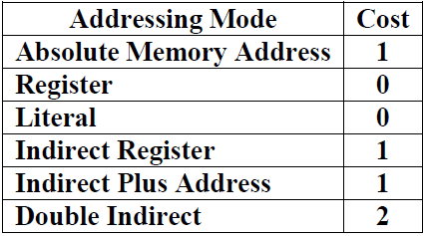

Calculate the total cost of following code segment. [4]

*a=b+c*

*d=b*

*param a*

*param d*

*call s, 3*

move b, r1

move c, r2

add r1, r2

param r1

param r2

call s,2

1. Cost : 1+1+0+0=2
2. 1+1+0+0=2
3. 1+0+0+0=1
4. 1+0+0+0=1
5. 1+0+0+0=1
6. 1+1+0+0=1

Total Cost = 8

1. Determine the set variable used and defined by following code fragment and also define the live variable at point of the code. [4]

j = 4

k = j + 1

j = 6 *(Point 01)*

m = k * j *(Point 02)*

t = m + 2

k = j + l*(Point 03)*

j = k +t

Use= {l}

Def={j,k,m,t}

Point one: Live = {j,k}

Point two: Live = {m,j}

Point three: Live ={k}

1. Define register descriptor with example. [2]

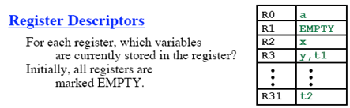

1. Define call graph with example. [2]
2. Determine the control flow graph of following instruction set. [4]



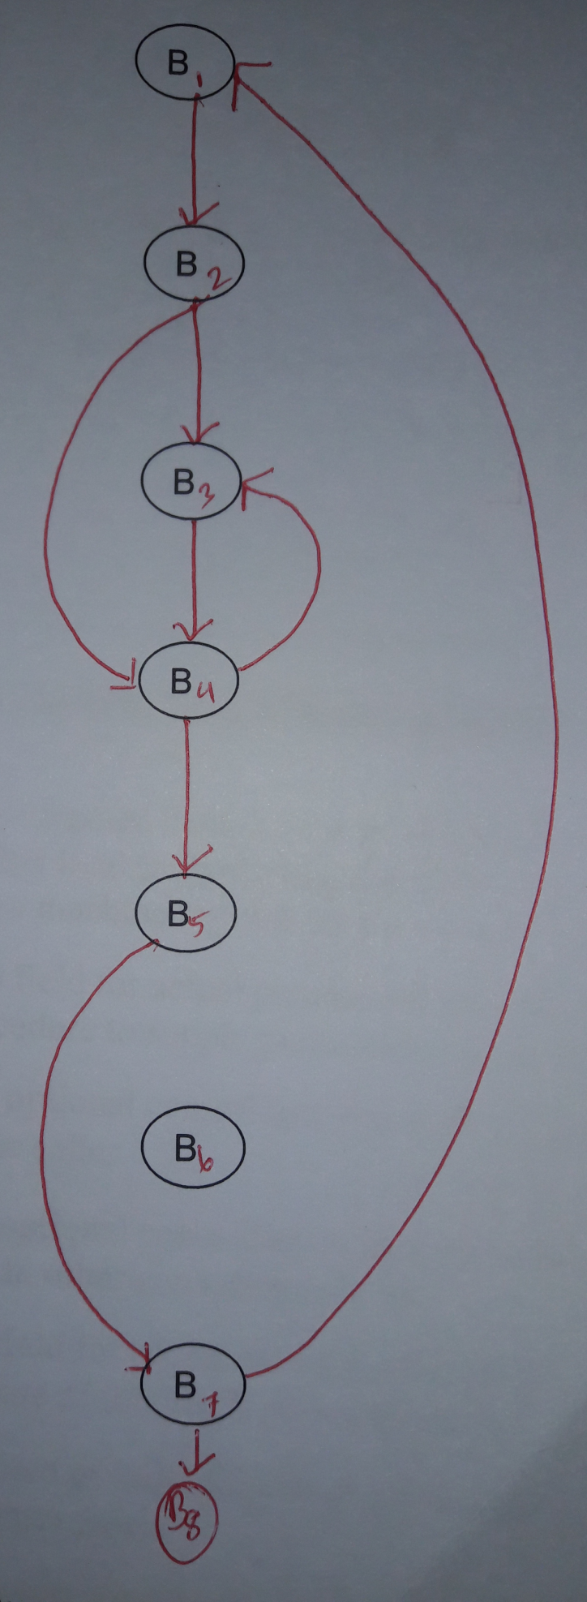

1. Following is the intermediate code to compute the dot product of two vectors A and B. Optimize this code by eliminating unnecessary operations and variables. [3]

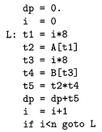

As same as set A